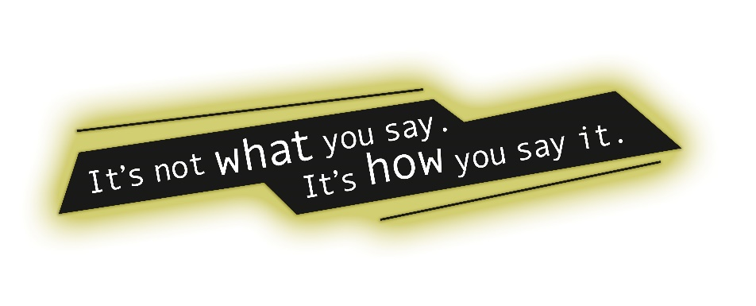
Tone Word Quizzes
What to expect on a tone quiz:
- 20 words per quiz
- Define the word
- Label the word by connotation (+, -, neutral)
- Describe a quote/image using the tone words and explain
- Describe a political cartoon using the tone words and explain
- Change one thing about the political cartoon, label it with a new tone, explain how the new tone is fitting.
Tone quiz schedule:
Every Friday you will have a tone quiz, starting 10/21/16. If there is not school on Friday the quiz will be rescheduled; teacher will determine the alternative testing date and post as necessary.
10/17/16 10/28/16 11/4/16 11/11/16
#1-20 # 21-40 #41-60 #61-80
11/18/16 12/2/16 12/9/16 12/16/16
#81-100 #101-120 #121-140 #141-160
1/6/17 1/13/17 1/20/17 1/27/17
#161-180 #181-200 #201-220 #221-240
2/3/17 2/10/17 2/17/17 2/24/17
# 241-260 #261-280 #281-300 #301-320
3/3/17
#321-336

Preparations for tone quizzes that teacher and students can participate in:
- Use of words in class discussion
- Practical/real world examples using the word in application (not the word in context)
- Quote analysis
Makeups:
Tone quizzes must be made up before school, after school, or during lunch. After 1 week in between quiz due date and student absence quiz will not be able to be made up.

